Stylistic Synonyms

🔹 What is Stylistic Synonyms
# Source: AI Source: Provided by: [Data Path: Persons Table -> ID Column: 1, Name_En Column: Motasem Essam] -> From: [Chatgpt (GPT-4-turbo)] on [7/30/2025]
Stylistic synonyms are words that have similar or identical meanings but differ in tone, formality, social usage, or literary style. They are used to match the stylistic context (e.g. formal vs informal, poetic vs technical) rather than just the literal meaning.

🧠 Definition:
# Source: AI Source: Provided by: [Data Path: Persons Table -> ID Column: 1, Name_En Column: Motasem Essam] -> From: [Chatgpt (GPT-4-turbo)] on [7/30/2025]
Stylistic synonyms are words that share a core meaning but differ in how, where, or by whom they are used, based on register, tone, or stylistic effect.
They are especially important in writing, rhetoric, and translation, where tone and audience matter.

📌 Key Features:
# Source: AI Source: Provided by: [Data Path: Persons Table -> ID Column: 1, Name_En Column: Motasem Essam] -> From: [Chatgpt (GPT-4-turbo)] on [7/30/2025]
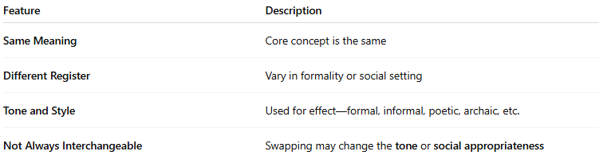
Feature | Description
Same Meaning | Core concept is the same
Different Register | Vary in formality or social setting
Tone and Style | Used for effect—formal, informal, poetic, archaic, etc.
Not Always Interchangeable | Swapping may change the tone or social appropriateness

📚 Examples of Stylistic Synonyms:
# Source: AI Source: Provided by: [Data Path: Persons Table -> ID Column: 1, Name_En Column: Motasem Essam] -> From: [Chatgpt (GPT-4-turbo)] on [7/30/2025]
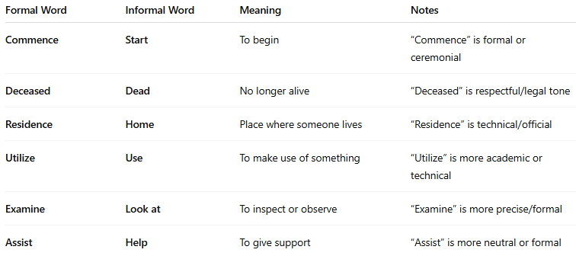
Formal Word | Informal Word | Meaning | Notes
Commence | Start | To begin | “Commence” is formal or ceremonial
Deceased | Dead | No longer alive | “Deceased” is respectful/legal tone
Residence | Home | Place where someone lives | “Residence” is technical/official
Utilize | Use | To make use of something | “Utilize” is more academic or technical
Examine | Look at | To inspect or observe | “Examine” is more precise/formal
Assist | Help | To give support | “Assist” is more neutral or formal

🧾 Other Types of Stylistic Variation:
# Source: AI Source: Provided by: [Data Path: Persons Table -> ID Column: 1, Name_En Column: Motasem Essam] -> From: [Chatgpt (GPT-4-turbo)] on [7/30/2025]
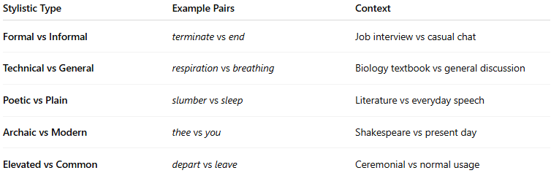
Stylistic Type | Example Pairs | Context
Formal vs Informal | terminate vs end | Job interview vs casual chat
Technical vs General | respiration vs breathing | Biology textbook vs general discussion
Poetic vs Plain | slumber vs sleep | Literature vs everyday speech
Archaic vs Modern | thee vs you | Shakespeare vs present day
Elevated vs Common | depart vs leave | Ceremonial vs normal usage

🔁 Comparison with Other Synonym Types:
# Source: AI Source: Provided by: [Data Path: Persons Table -> ID Column: 1, Name_En Column: Motasem Essam] -> From: [Chatgpt (GPT-4-turbo)] on [7/30/2025]
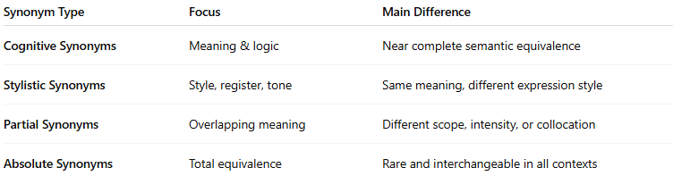
Synonym Type | Focus | Main Difference
Cognitive Synonyms | Meaning & logic | Near complete semantic equivalence
Stylistic Synonyms | Style, register, tone | Same meaning, different expression style
Partial Synonyms | Overlapping meaning | Different scope, intensity, or collocation
Absolute Synonyms | Total equivalence | Rare and interchangeable in all contexts

